**Sporty Shoes(E-commerce website)**

(Documentation)

Project Name:- Sporty Shoes(E-commerce website)

Project Developer :- Priya Naveen

Objectives of Project:-

* Sporty Shoes is a company that manufactures and sells sports shoes. They have a walk-in store, and now, they wish to launch their e-commerce portal sportyshoes.com.

* Here developing a prototype of the application. It will be then presented to the relevant stakeholders for budget approval. Your manager has set up a meeting where you’re .
* Presenting the specification document which has the product’s capabilities, appearance, and user interactions.
* Setting up Git and GitHub account to store and track your enhancements of the prototype .
* Explaining the Java concepts used in the project
* Discussing the generic features of the product:
* There will be an admin to manage the website. An administrator login will be required to access the admin page.
* Sprint

One sprint taken

And its time period is 3 weeks 15 worling days

|  |  |
| --- | --- |
| ConFig | Value |
| Sprint Start | 21/04/2022 |
| Sprint End | 02/05/2022 |
| Daily Hours | 9 |
| Focus Factor | 95% |
| No. Weeks | 3 |
| Working Days | 15 |
| Work Hours | 135 |
| Available WH | 99 |

|  |  |  |
| --- | --- | --- |
| Name | Role | Contribution |
| Priya Naveen | FSD | 100% |
| Priya Naveen | QA | 100% |
| Priya Naveen |  |  |

|  |  |  |  |  |
| --- | --- | --- | --- | --- |
| Story Name | Story Points | Hours For Fed | Hours For Bed | Hours For QA |
| As the Hr Manager I want | 13 | 30 | 2 | 22 |
| As a Manager | 13 | 70 |  |  |
| As a User | 8 |  | 2 | 20 |

Algorithm:-

Step1:- Start

Step2:- Creating a Maven Project which is web enabled.

Step3:- Create class SportyShoesApplication.

Step3:- Create Controllers classes 1.Admin Controller.java 2.Category controller.java

3.Product Controller.java 4.Purchase Controller.java 5.User Controller.java

Step4:- create Entity classes 1.Admin.java 2.Category.java 3.Product.java

4.Purchase.java 5.User.java

Step5:- create Interfaces Repo 1.AdminRepository.java 2.CategoryRepository.java

3.ProductRepository.java 4.PurchaseRepository.java 5.UserRepository

Step6:- create Response clasess 1.CategoryResponse.java 2.ProductResponse .java

3.UserResponse.java

Step7:- create services 1.AdminService 2.Category Service 3.ProductServiece

4.PurchaseServiece 5.UserServiece.

Step8:- Before building the project, we need to confirm that the servlet.jar has been added to the project.

Step9:- End

FlowChart:-

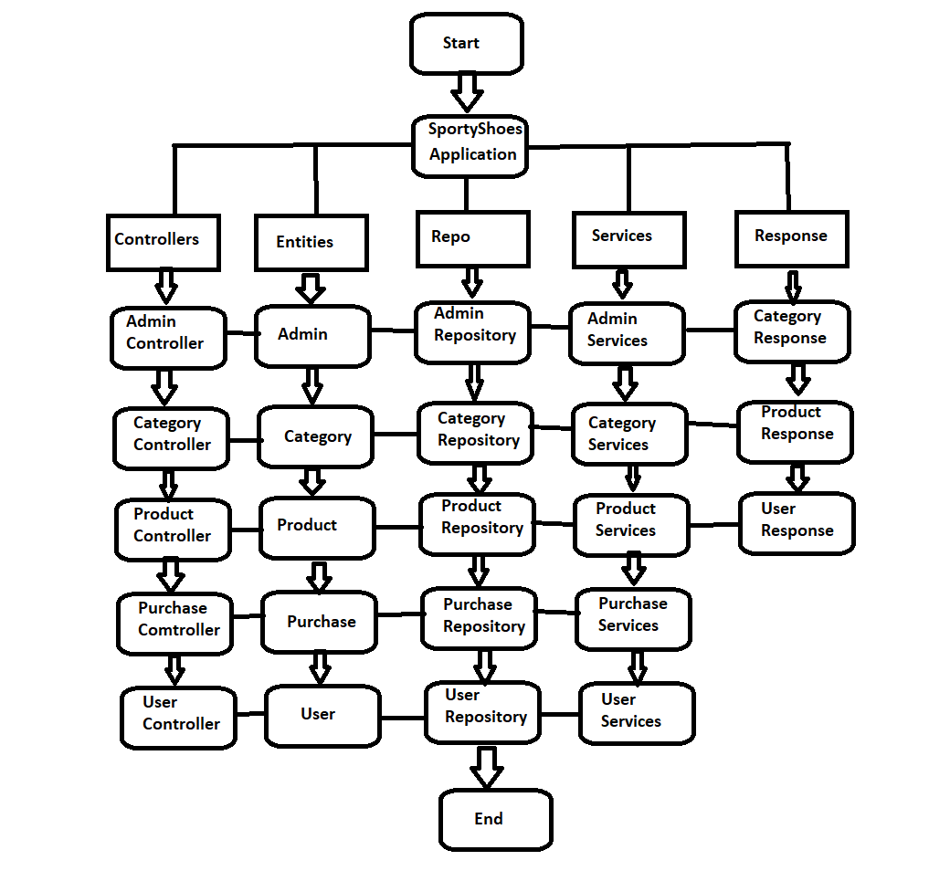

Features :-

* Manage the products in the store including categorizing them
* Browse the list of users who have signed up and be able to search users
* See purchase reports filtered by date and category

**Tools used for development**:

1. Eclipse IDE

2. MySQL Relation Database Management System

3. Apache Tom-Cat 10 server

4. Java Server Pages (JSP)

5. Apache Maven

6. JDBC Java Database Connectivity

Unique selling Point:-

“Quality Matters here, The Next Quality ”